**Assignment -1**

1. Split this string

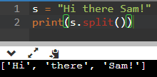

1. Use .format() to print the following string.

Output should be: The diameter of Earth is 12742 kilometers.

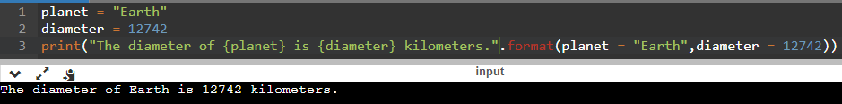

1. In this nest dictionary grab the word "hello"

d = {'k1':[1,2,3,{'tricky':['oh','man','inception',{'target':[1,2,3,'hello']}]}]}

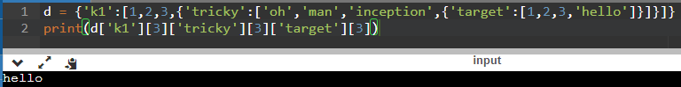

1. Numpy
   1. Create an array of 10 zeros?

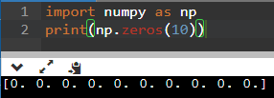

* 1. Create an array of 10 fives?

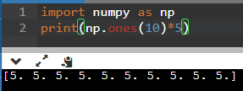

1. Create an array of all the even integers from 20 to 35

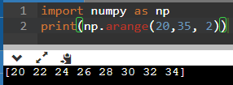

1. Create a 3x3 matrix with values ranging from 0 to 8

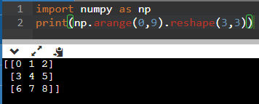

1. Concatenate a and b

a = np.array([1, 2, 3]), b = np.array([4, 5, 6])

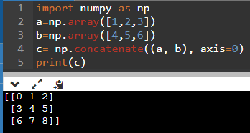

1. Pandas
   1. Create a dataframe with 3 rows and 2 columns

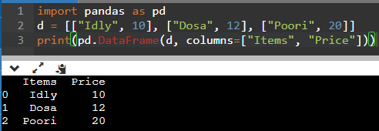

1. Generate the series of dates from 1st Jan, 2023 to 10th Feb, 2023

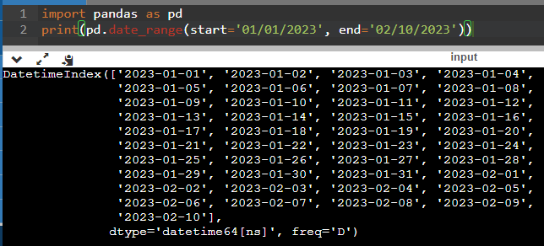

1. Create 2D list to DataFrame

lists = [[1, 'aaa', 22], [2, 'bbb', 25], [3, 'ccc', 24]]

